Tutorial: Harp-DAAL for
High Performance Big Data Machine Learning
9:45 am – 12:00 pm on November 12, 2017, HPCDC Conference, Denver, Colorado

Objective

In this tutorial, you will learn about scalable Machine Learning on HPC-Cloud. Harp (Hadoop plugin) provides communication patterns and invokes Intel® Data Analytics Acceleration Library (DAAL) with the fastest machine learning algorithms on Xeon™ or Xeon Phi™ architectures.
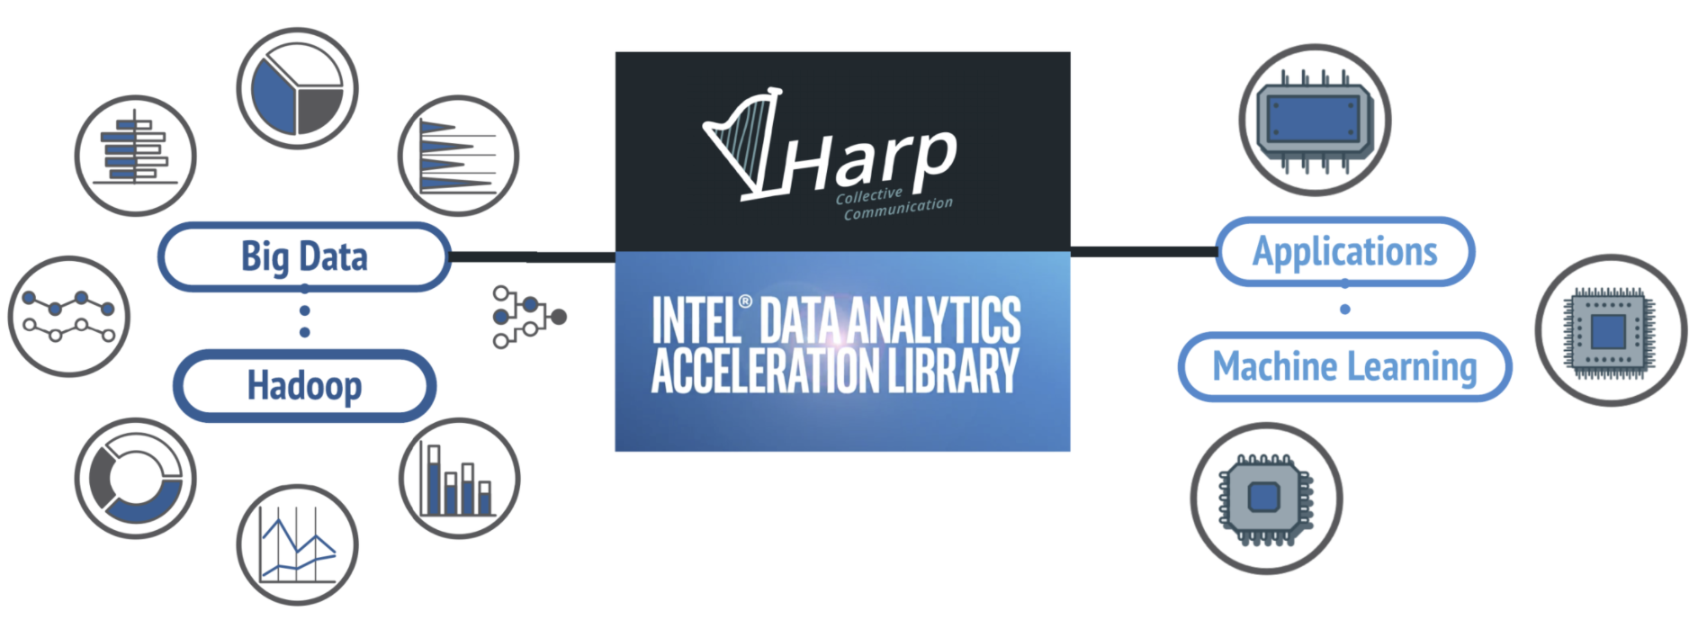
For Developers | For Users | AI & You
We introduce Harp-DAAL, a high-performance machine learning framework. | Simple Python interface and run scalable machine learning applications on Google Cloud. | This tutorial clarifies what type of hardware and software is needed for scalable machine learning.
Hands-on examples
 | Examples | Learning Tasks
Applications | Image Clustering with Kmeans | Classification
 | Text Categorization with Naïve Bayes | Classification
 | Recommender System with MF-SGD | Recommender System
 | Naive Bayes | Classification
 | Neural Network
 | Linear Regression | Regression
Algorithms | Ridge Regression
 | K-means | Clustering
 | Matrix Factorization(SGD) | Recommender System
 | Matrix Factorization(ALS)
 | SVD, PCA, QR | Dimension Deduction
 | Moments, Covariance | Statistics
Tutorial website: https://dexterrules.github.io/SC-Demo-17/SC-Demo.html

